**CODE:**

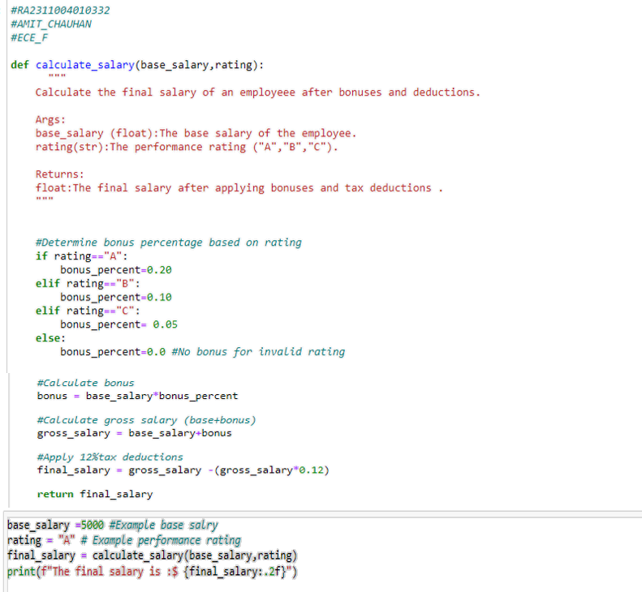

**OUTPUT:**

**CODE:**

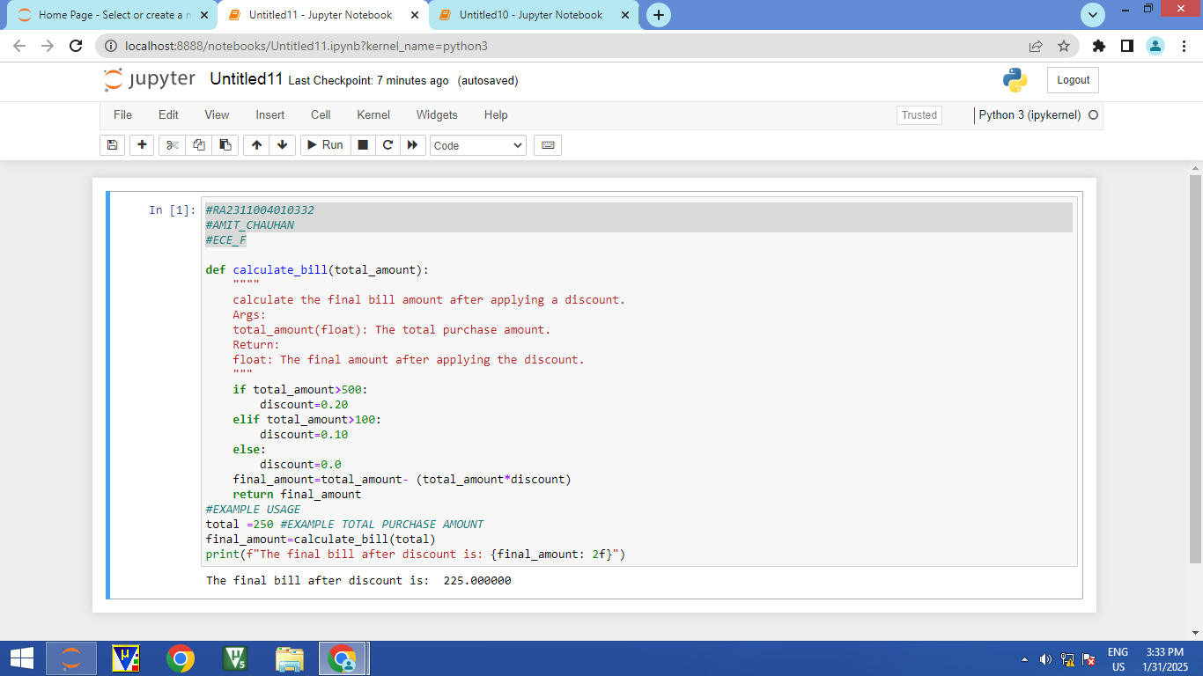

**OUTPUT:**

